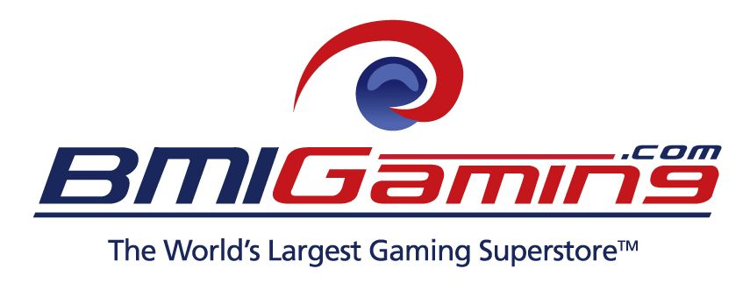
[FOR IMMEDIATE RELEASE]
2014 Best Of Show Arcade Machine Awards Revealed To Public
Annual BOSA Awards for Arcade Machine innovation and creativity
announced jointly by BMIGaming.com and The Stinger Report today
[Feb 27, 2014 - Boca Raton, FL] - Marking its third year, and now with strong worldwide amusement
industry recognition, BMIGaming.com and The Stinger Report announced today the highly anticipated
Best Of Show Arcade Machines Awards (BOSA) for 2014.
The BOSA Awards recognize the best of new arcade machine innovations and applications, as seen
within the global amusement industry throughout 2013, with the awards noting creativity, innovation
and originality in new arcade machines introduced in the amusement device and arcade game sectors.

The BOSA has quickly become a noted ”mark of excellent” within the industry for new products releases,
Growing in size each year, the BOSA Awards will continue to chart new arcade gaming trends and use
of exciting and innovative new technologies that will shape the digital out-of-home entertainment arena.
New for 2014, the BOSA continues to expand its reach, with the inclusion of a new awards category
for ‘Physical Action / Sports Arcade Games‘, for a total of four product categories which cover both
ground-breaking and significant arcade machine and amusement device product releases in 2013.
After an exhaustive review of the latest arcade machines, including many new products released
at the recent IAAPA Amusement Expo in Orlando, FL, and through a very arduous voting process,
the 2014 BOSA Award winners are ready to be unveiled. Each category has only the potential for
products to be awarded a Gold, Silver or Bronze Medal, or “Notable Mention” Award.
The BOSA Awards finalists were judged internally by the staff at both BMIGaming.com and The Stinger
Report, based on products reviewed throughout 2013 and at the annual IAAPA Amusement Expo.
Finalists for the Best Of Show Arcade Machine Awards are assigned weighted point scores by our panel
of (7) judges using all of these six factors : Game Originality, Game Uniqueness, Game Playability and
Enjoyment, Market Relevance, Earning Potential and Product Pricing. The physical BOSA Awards will
be handed out during the upcoming Amusement Expo in Las Vegas during the end of March, 2014
Category One : Video Arcade Games
Gold Medal Award - “ Mach Storm Arcade ” | VIDEO | PHOTO
Incredible 180° dome display offers a exhilarating jet simulator dog ighting experience - By Bandai Namco Games
Silver Medal Award - “ Batman Arcade ” | PHOTO

Save Gotham City as the “Dark Knight” in this exclusive Batmobile driving arcade game - By Raw Thrills
Bronze Medal Award - “ Overtake Arcade ” | PHOTO
Over-the-top stunt driving meets high octane street racing in this new video arcade game - By Wahlap Tech
Notable Mention Award - “ Mario Kart Arcade GP DX ” | PHOTO
Revised version of this venerable kart-racing video arcade game, now with online play – By Bandai Namco Games
(Con’t)
Category Two : Videmption Arcade Games
Gold Medal Award - “ Jetpack Joyride Arcade ” | VIDEO | PHOTO
Jet your way to glory in this new arcade version of the popular mobile app game - By Adrenaline Amusements
Silver Medal Award - “ SpongeBob SquarePants - Hit The Beat ” | PHOTO
Fun and unique “kid-friendly” music rhythm game featuring Spongebob Squarepants - By Andamiro Entertainment
Bronze Medal Award - “ Monopoly Arcade ” | PHOTO
The timeless and classic board game brought to real life in a fantastic videmption arcade game - By ICE Games
Notable Mention Award - “ Rail Rush Arcade ” | PHOTO

Mobile games are better in a big screen arcade cabinet and Rail Rush is no exception - By Coastal Amusements
Category Three : Redemption Arcade Games
Gold Medal Award - “ Lobster Robot ” | VIDEO | PHOTO
Grab and drop balls into goals with your robotic lobster in this unique redemption game - By Andamiro Entertainment
Silver Medal Award - “ Down The Clown Arcade ” | PHOTO

New carnival-style throwing-knock down ticket redemption arcade game - By ICE Games
Bronze Medal Award - “ ICE Ball FX ” | PHOTO
Alley Rollers finally jump into the 21st century thanks to a colorful LED light-show upgrade - By ICE Games
Notable Mention Award - “ Snow Down Arcade ” | PHOTO

Catch the most snowflakes (minus the cold) in this innovative new game - By Jennison Entertainment Technologies
Category Four : Physical / Sports Arcade Games
Gold Medal Award - “ Galaxy Collision Quad Air ” | VIDEO | PHOTO
Competitive and highly unique 2, 3 or 4-player square-shaped air hockey game - By Barron Games International
Silver Medal Award - “ DiscGlo Shuffle ” | PHOTO

Unique virtual shuffleboard / bowling ticket redemption game with color-changing LED lighting - By Arachnid
To view exclusive live-active, high-definition video clips, product pictures and receive
more information on all the 2014 BOSA Award arcade machine winners, please visit :

http://www.bmigaming.com/arcade-machine-awards-bosa.htm
(Con’t)
BOSA Award Presenter Backgrounds :

BMIGaming.com / BMI Worldwide -
The world's largest online distributor of amusements, arcade games, redemption games, motion theaters
and simulators, sports games, kiddie rides and vending equipment, with over 1600 commercial-quality
products for sale to over 100 countries worldwide, specializing in arcade, family entertainment center
and LBE site feasibility studies, arcade design, theming, build-out, marketing and consulting services.
BMI Worldwide is headquartered in Boca Raton, FL, with domestic offices in Salt Lake City, UT and
Myrtle Beach, SC, and international sales offices in Bogota, Colombia and Cape Town, South Africa.
http://www.bmigaming.com
The Stinger Report / KWP Limited -
Specialists in the 'pay-to-play' industry and scene consultancy, and prolific commentator through
The Stinger Report on the emergence of new entertainment markets and amusement technologies.
KWP Limited is also the founder of the not-for profit DNA Association and DNA Conferences, which
focus exclusively on the Digital Out-of Home interactive entertainment (DOE) sector.
http://www.thestingerreport.com | http://www.dna-association.com
Press Contacts | Digital Assets Requests :

David Young
Founder & CEO | BMI Worldwide, Boca Raton, FL | Phone : + 561-922-5162 | Email : david@bmigaming.com

Kevin Williams
Publisher | The Stinger Report, London, UK | Phone : + 44-7785-254729 | Email : kwp@thestingerreport.com
[END]

