Best of show arcade machine awards | 2 017
2017 BOSA Arcade Machine Award Winners Revealed
BMIGaming.com Announces Annual ‘ Best Of Show Awards ’ for New Amusement Devices
(Boca Raton, FL) - Apr 25, 2017 – BMIGaming.com, in conjunction with The Stinger Report and Arcade Heroes announced
the winners of the annual Best Of Show Arcade Machine Awards today. The BOSA Awards is a independent amusement products awards program, judged solely by members of the amusement press and prominent arcade industry pioneers.
Amusement Companies awarded a BOSA Medal this year include Raw Thrills (3 Awards), Universal Space (2 Awards),
LAI Games (2 Awards), with Nintendo, Bandai Namco Games, Adrenaline Amusements, Coastal Amusements,
Atari Games, DOF Robotics, Andamiro Entertainment, VRStudios, Team Play, CJ 4DPlex, Fun VR Tech, Taito,
Virtuix Omni, Unit-e and World's Fastest Drummer (WFD), all receiving a single BOSA Award.
The Sixth Annual Best Of Show Arcade Machine Awards, which covers new and emerging out-of-home amusement
and arcade technology and innovations as seen at the recent IAAPA Attractions Expo in Orlando, Florida, was the
most competitive in its history, with the highest number of contenders to date, and with the most distinguished
judging panel yet assembled. BOSA Nominees included a vast array of both established and new amusement firms
The Best Of Show Arcade Awards 2017 covered four product categories this year, including 1) Video Arcade Games,
2) Video Redemption (Videmption) Arcade Games, 3) Redemption Arcade Games, and 4) Immersive Gaming, which
includes VR / Virtual Reality Gaming Systems, Virtual Reality Rides, Motion Simulator Rides and Motion Theaters.
The criteria used to select BOSA Award Winners are based on products reviewed at the IAAPA Expo, and products must
be expected to ship by early Summer 2017 to qualify. Qualifying products are then reviewed and nominated for a BOSA Award by our panel of judges, then voted upon, with BOSA Nominees assigned a weighted product score after a full
review and lengthy ‘live’ debate between the judges, with the final scoring based on these areas of importance :
Originality, Uniqueness, Playability + Enjoyment, Relevance, Market Earning Potential and Product Pricing.
To get more information for all 2017 BOSA / Best Of Show Arcade Machine Award winners, along with game pictures, product dimensions, product descriptions, product brochures, product videos and much more, please visit :
http://www.bmigaming.com/bosa-arcade-machine-awards-2017.htm
Best Of Show Arcade Awards | Category One : Video Arcade Games
BOSA 2017 Gold Medal Award | The Walking Dead Arcade | From Raw Thrills / PlayMechanix
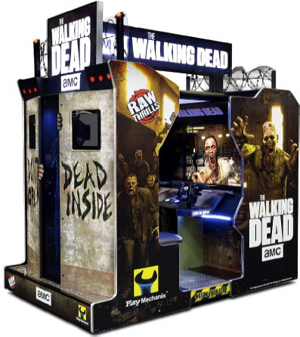 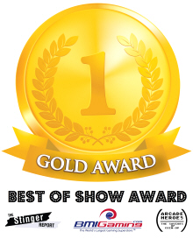
BOSA 2017 Silver Medal Award | World’s Fastest Drummer | From WFD / Unit-E
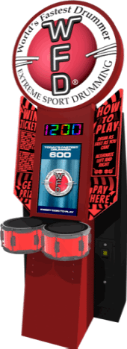 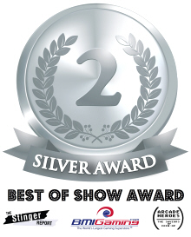
BOSA 2017 Bronze Medal Award | Cruis’n Blast Arcade | From Raw Thrills / Nintendo
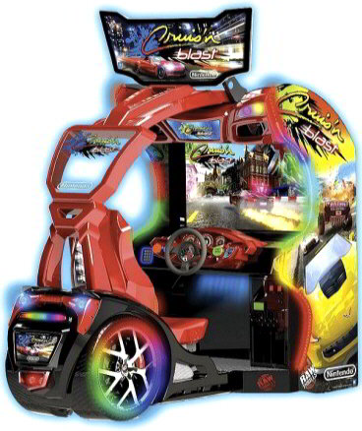 
BOSA 2017 Honorable Mention Award | Outback Hunter / Dino Invasion | From UNIS
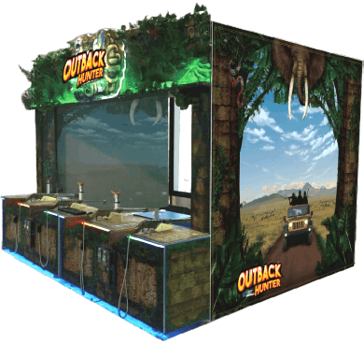 
Best Of Show Arcade Awards | Category Two : Videmption Arcade Games
BOSA 2017 Gold Medal Award | Crazy Tower Arcade | From Adrenaline Amusements
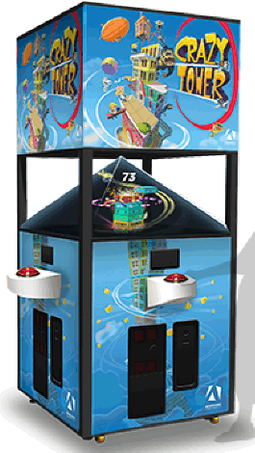
BOSA 2017 Silver Medal Award | Space Invaders Frenzy | From Raw Thrills / Taito
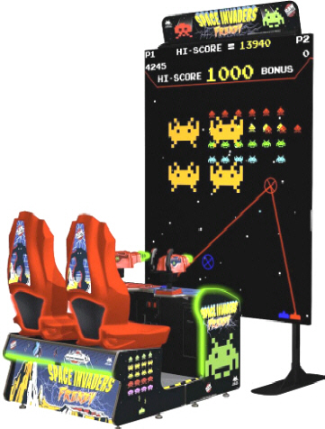
BOSA 2017 Bronze Medal Award | Atari Breakout Arcade | From Coastal Amusements / Atari
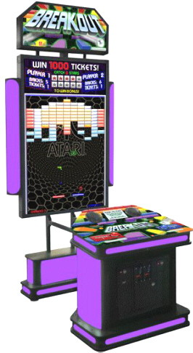
BOSA 2017 Honorable Mention Award | Launch Code Arcade | From Team Play, Inc.
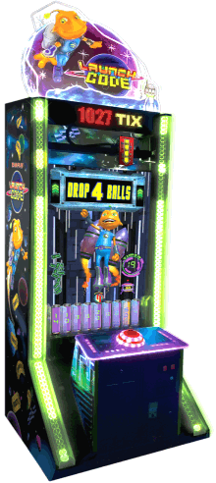
Best Of Show Arcade Awards | Category Three : Redemption Arcade Games
BOSA 2017 Gold Medal Award | Baseball Pro Arcade | From Andamiro Entertainment
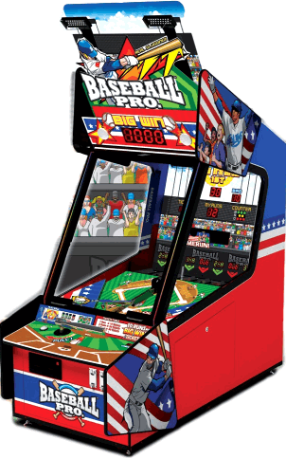
BOSA 2017 Silver Medal Award | Let’s Bounce Arcade | From LAI Games
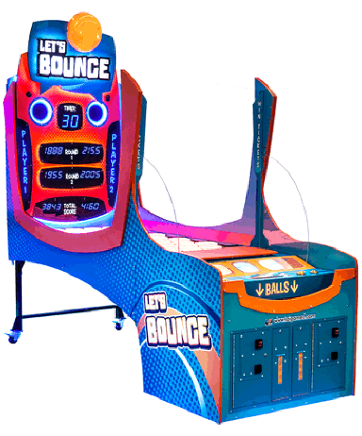
BOSA 2017 Bronze Medal Award | Hyper Shoot Basketball | From LAI Games
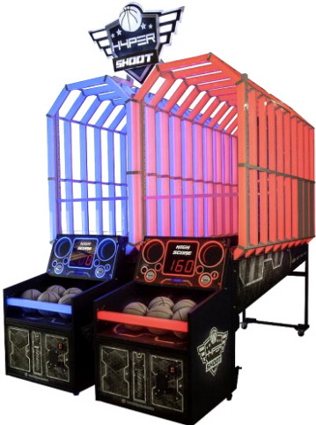
BOSA 2017 Honorable Mention Award | DC Superheroes Arcade | From Bandai Namco
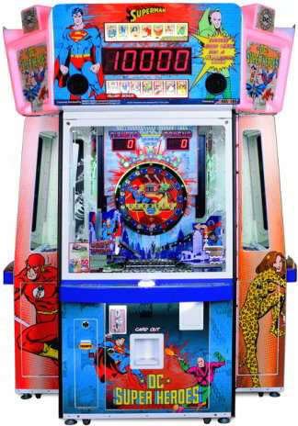
Best Of Show Arcade Awards | Category Four : VR / Motion Simulators
BOSA 2017 Gold Medal Award | VRcade Gaming System | From CJ 4DPlex / VRStudios
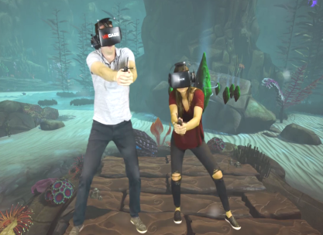
BOSA 2017 Silver Medal Award | Hurricane 360 VR Motion Ride | From DOF Robotics
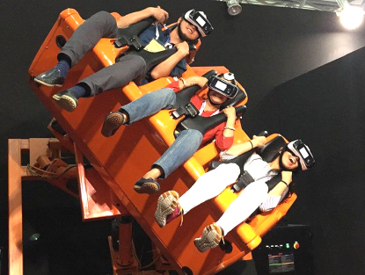
BOSA 2017 Bronze Medal Award | Omni Arena VR | From Fun VR Tech / Virtuix Omni
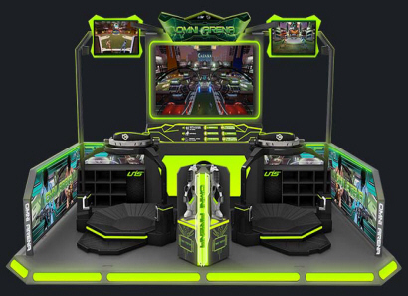

[CON’T]
To get more information on all 2017 BOSA / Best Of Show Arcade Machine Award winners,
along with game pictures, product dimensions and brochures, prices and more, please visit :

http://www.bmigaming.com/bosa-arcade-machine-awards-2017.htm
BOSA Award Presenter Backgrounds

BMI Worldwide / BMIGaming.com is a global amusement products distributor and arcade
industry consultant, specializing in arcade facility development, design, floor planning and
installation services for Family Entertainment Centers (FEC) and other Location Based
Entertainment (LBE) venues worldwide, with headquarters based in Boca Raton, Florida,
and international sales offices located in Bogota, Colombia and Cape Town, South Africa.
BMI Worldwide is notable as having the world's most visited and most comprehensive arcade
and amusement products website in existence, with over 1.5 Million global visitors in 2016, and
offers over 1400 products, from arcade games, video games, redemption games, sports games,
motion theaters. motion simulators and virtual reality games, from over 80 global manufacturers.
http://www.bmigaming.com

The Stinger Report - This highly acclaimed, widely circulated newsletter published bi-weekly
since 1994 provides global subscribers up-to-date news and feature reports covering all facets
of the worldwide amusement, arcade and digital "out-of-home" (DOOH) entertainment sector.
TSR specializes in publishing "insider" industry information on the current trends and news in
the amusement world - Since launching in 1994, TSR has provided industry news, hard-hitting
investigative reports, "behind-the-scenes" expose, product reviews on new arcade machines,
motion simulators, amusement and entertainment products, along with very thought-provoking
articles and in-depth analysis on the current and future state of the global amusement
Click here for a free subscription to The Stinger Report Newsletter
[CON’T]

Arcade Heroes - This widely recognized arcade and out-of-home entertainment news and video
review website was launched back in 2006 by a couple of UK arcade enthusiasts who saw the
blogosphere as an opportunity to provide readers with a reliable source of detailed arcade industry
news and game reviews, which at the time had almost completely stopped, except for a handful of commercial new sources. After its launch, Arcade Heroes (AH) grew as The Stinger Report began
to contribute arcade industry stories. In 2007, Adam Pratt (AH's Owner and Publisher since 2010)
first joined the AH Editorial Team, and was quickly followed by many other US-based contributors.
Adam Pratt (aka "Shaggy ") is a very avid arcade fan, and along with publishing AH, also owns
The Game Grid Arcade in Salt Lake City, Utah, which provides him a very unique perspective
in covering arcade games and news from the point-of-view of a both a Player and Operator.
http://www.arcadeheroes.com
2017 BOSA Awards Press Contacts | Digital Assets Requests :
Ms. Theresa Landman  BMI Worldwide | Cape Town, SA  US : + 561.288.4890  Email : theresa@bmigaming.com  Skype : theresa.bmigaming | Mr. Kevin Williams  The Stinger Report | London, UK  UK : + 44.7785.254729  Email : kwp@thestingerreport.com  Skype : kevinw729

[END]

