**FOR IMMEDIATE RELEASE**  
***Bumper Year For New Arcade Machines – The 2015 BOSA Awards For Best New Arcade  
Game Products Presented To Excited Amusement Industry Manufacturers In Las Vegas.***  
**Las Vegas, NV (PRWEB) Apr 21, 2015** **-** Taking the center stage for global amusement awards,[***BMIGaming.com***](http://www.bmigaming.com/)   
and [***The Stinger Report***](http://www.thestingerreport.com/) celebrated their annual presentation of the [***Best Of Show Arcade Machine Awards***](http://www.bmigaming.com/bosa-arcade-machine-awards.htm) at  
the recent *2015* [***Amusement Expo***](http://www.amusementexpo.org/) in Las Vegas, handing out the coveted amusement award to a handful of   
highly appreciative and innovative arcade and amusement industry manufacturers on the show floor this year.  
  
This year’s highly contested***BOSA Awards*** saw many of the leading trend-setting and revenue generating amusement, redemption and attraction pieces being singled out. The *BOSA Awards* also rose to a new level of influence within the  
industry this year, with many *BOSA Award* recipients actively displaying their award status in their booths at the show.   
  
Many trade attendees on the show floor noted that the *BOSA Awards* have become one of the most accurate predictors  
of new amusement machine market popularity, and provides a high “recognition factor” amongst arcade industry buyers.



Over 50 new products in four product categories were closely evaluated by the panel of judges from *BMIGaming.com*and *The Stinger Report*  this year, and twelve amusement manufacturers were selected to win the 2015 *BOSA Awards* :  
  
The highlight of this year’s awards is the new **Motion / Interactive Theaters and Rides** category, which demonstrates  
the continued growth of *BOSA Awards*, with the first Gold Award in this category presented to *Simuline* for their unique  
***Valkyrie Interactive Motion Theater Ride*** and a Silver Award to *DOF Robotics* for the ***SuperNova XD Cinema Ride***  
For the **Video Arcade Games** category, the Gold Award went to *Raw Thrills* for ***Jurassic Park Arcade Motion Deluxe***,  
the Silver Award given to *SEGA* for ***Showdown Special Attraction***, the Bronze Award to *Andamiro Entertainment* for  
***Pump It Up Prime 2015***, and the Honorable Mention Award to *Universal Space (UNIS)* for ***Armed Resistance DLX***.   
  
In the **Video Redemption / Videmption Games** category, *Team Play* scored the Gold Award for ***Fishbowl Frenzy***,  
the Silver went to *Innovative Concepts In Entertainment* for their ***Kung Fu Panda Arcade : Dojo Mojo***, the Bronze  
to *Adrenaline Amusements* for ***Flying Tickets Arcade***, and Honorable Mention to *LAI Games* for ***Shooting Mania***.   
  
The **Redemption Arcade Games** category saw the Gold going to *Universal Space* for ***Panning For Gold Arcade***,  
the Silver to *Toccata Gaming* for ***Zombie Snatcher***, the Bronze to *Benchmark Games* for ***SpinDrome***, and the  
Honorable Mention Award going to *Innovative Concepts In Entertainment* for ***Gold Fishin’ Arcade***.

The *BOSA Awards* present a widely respected platform showcasing the best in new amusement machine innovation,  
and over the years has become a highly influential tool in shaping the purchasing decisions of arcade machine buyers worldwide. Judging for this year’s awards was conducted on the show floor of the annual *IAAPA Amusement Expo* held  
in Orlando, FL, with the judges undertaking a industry-unique process of live, hands-on product gameplay and review of  
all new arcade products on display, then conducting a long, demanding evaluation and selection of the reviewed games  
to determine what we think are the most innovative, eye-catching and unique products for each *BOSA Awards* category.  
  
This year also saw the test launch of the new [***Peoples’ Choice Awards***](http://www.bmigaming.com/bosa-pca-2015-vote.htm) (PCA), which although is *not* affiliated with the  
annual *BOSA Awards*, does allows the general public to vote on *BOSA Award* nominees, via an interactive online poll.   
  
Based on the feedback gained from this new approach of measuring arcade game popularity online by the end-user,   
the BOSA team is considering expanding the *PCA*, but moving it to the fourth quarter after the *BOSA Awards* are  
announced, so end-users can play and experience first-hand all BOSA-nominated games, before voting on them.  
  
  
(con’t)  
  
  
  
  
  
***Special Note :*** *Two amusement manufacturers,* ***Baytek Games*** *and* ***Bandai Namco Games*** *were excluded from the 2015  
BOSA Awards nomination process, due to their request for us* ***not*** *to review their products at the IAAPA Amusement Expo.*  
  
**Pictures of this year’s *BOSA Award W*inners receiving their award plaques are shown on the pages below**, plus exclusive “live-active” product video clips, product pictures, dimensions, prices and detailed information for all of the   
2015 ***BOSA Award*** Arcade Machine Winner’s products can be found at :   
  
[**http://www.bmigaming.com/bosa**](http://www.bmigaming.com/bosa)  
**Pictures : 2015 BOSA Award Winners** (Taken at Amusement Expo 2015 , Las Vegas, NV)



**RAW THRILLS | “ Jurassic Park Arcade Motion Deluxe “** (L-R) **Mark Struhs, George Petro, Eugene Jarvis** (Raw Thrills)**, David Young, Jay Fleming** (BMIGaming.com)   
(con’t)  
  
  
 **TEAM PLAY, INC. | “ Fishbowl Frenzy “** (L-R) **Ed Pellegrini, Geno Giuntoli, Frank Pellegrini** (Team Play), **Jay Fleming** (BMI Gaming), **Ken Fedesna (**Team Play) **ANDAMIRO ENTERTAINMENT | “ Pump It Up Prime 2015 “** (L-R) **David Young** (BMI Worldwide), **Satinder Bhutani** (Andamiro), **Jay Fleming** (BMIGaming.com)  
  
  
 **INNOVATIVE CONCEPTS IN ENTERTAINMENT | “ Kung Fu Panda Arcade : Dojo Mojo “ + “ Gold Fishin’ Arcade “**  (L-R) **David Young** (BMI Worldwide), **Greg Kania** (ICE), **Jay Fleming** (BMIGaming.com)  
 **BENCHMARK GAMES | “ SpinDrome “** (L-R) **David Young** (BMI Worldwide), **Al Kress** (Benchmark Games), **Jay Fleming** (BMIGaming.com)  
  
 **UNIVERSAL SPACE (UNIS) | “ Panning For Gold “ + “ Armed Resistance DLX “**  (L-R) **David Young** (BMI Worldwide), **Steven Tan** (Universal Space), **Jay Fleming** (BMIGaming.com)  
 **TOCCATA GAMING INTERNATIONAL | “ Zombie Snatcher “**  (L-R) **David Young** (BMI Worldwide**)**, **Todd Stimac** (Toccata Gaming), **Jay Fleming** (BMIGaming.com)  
  
  
 **LAI GAMES | “ Shooting Mania Arcade ”** (L-R) **David Young** (BMI Worldwide), **Chris Brady, Marshall Ashdown** (LAI Games), **Jay Fleming** (BMIGaming.com)  
 **SEGA AMUSEMENTS | “ Showdown Special Attraction “**  (L-R) **David Young** (BMI Worldwide**)**, **Peter Gustafson** (Sega Amusements), **Jay Fleming** (BMIGaming.com)

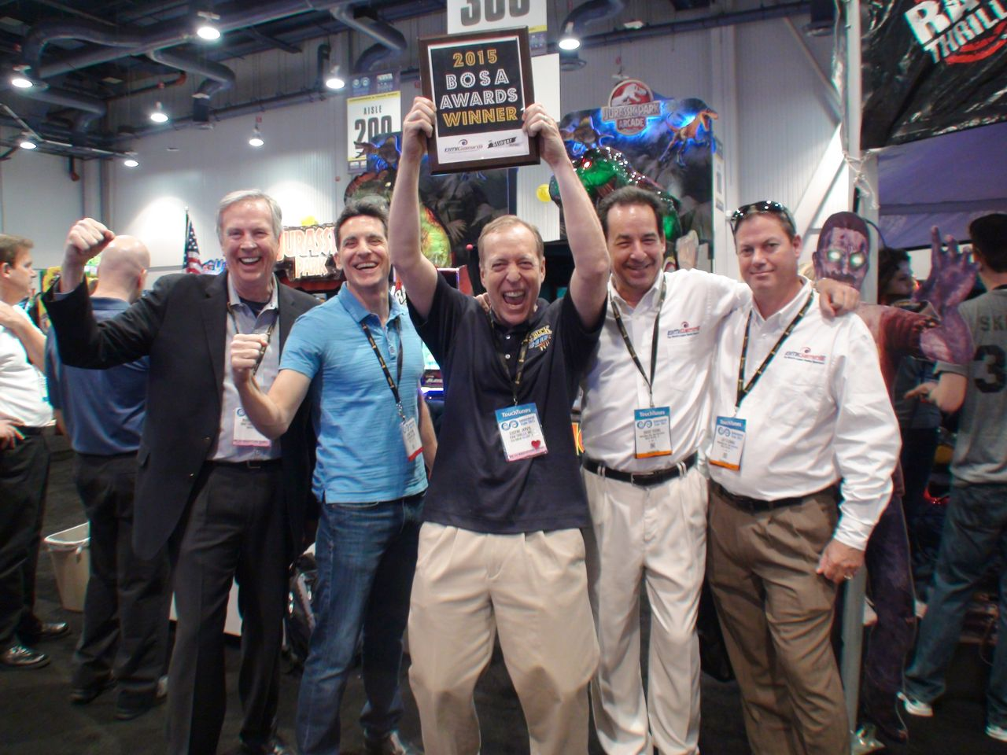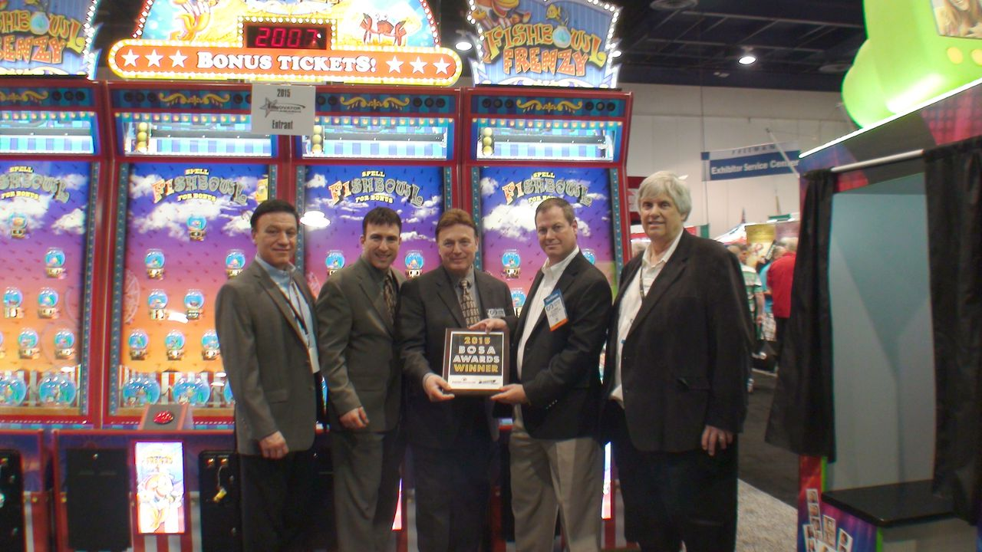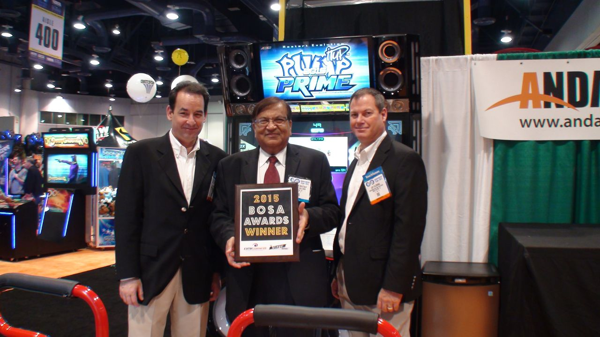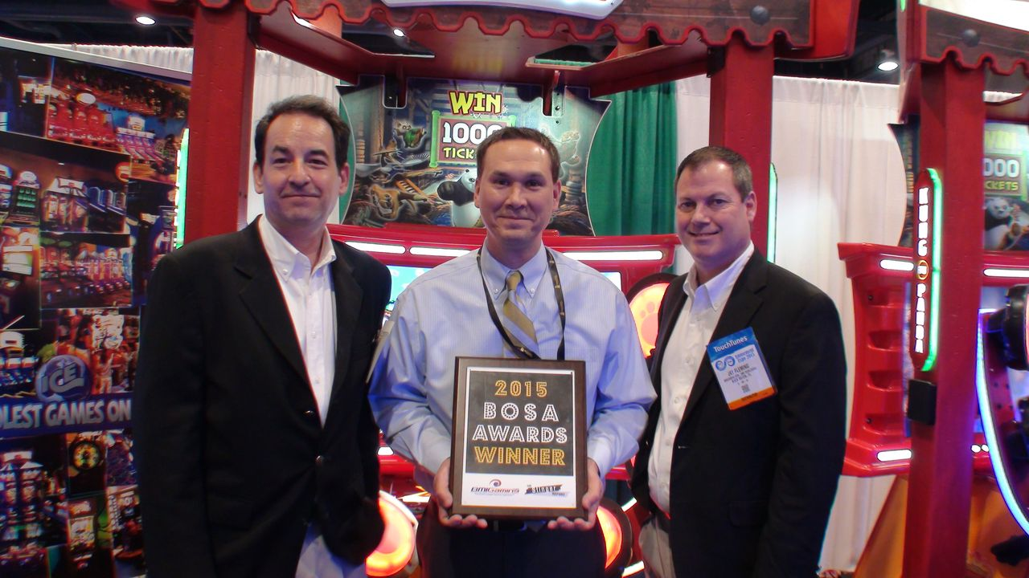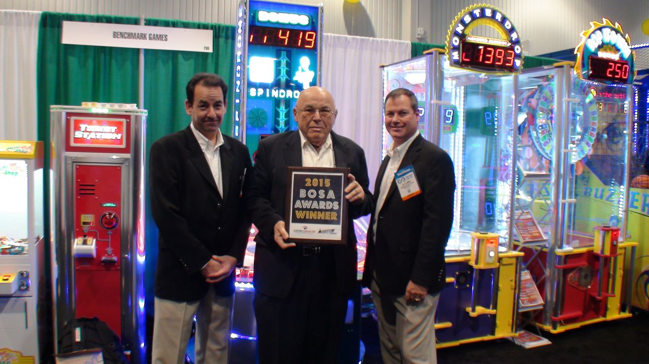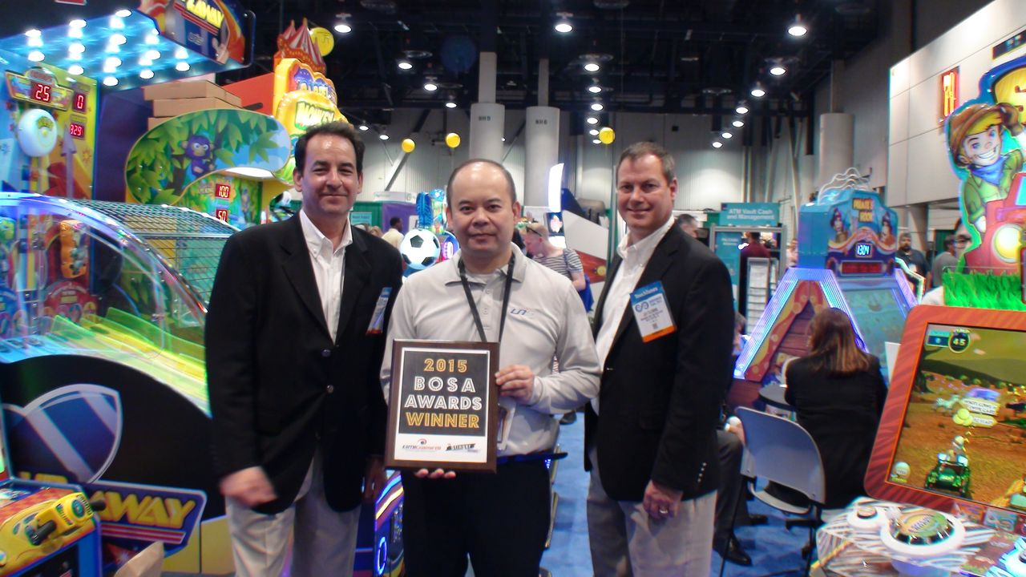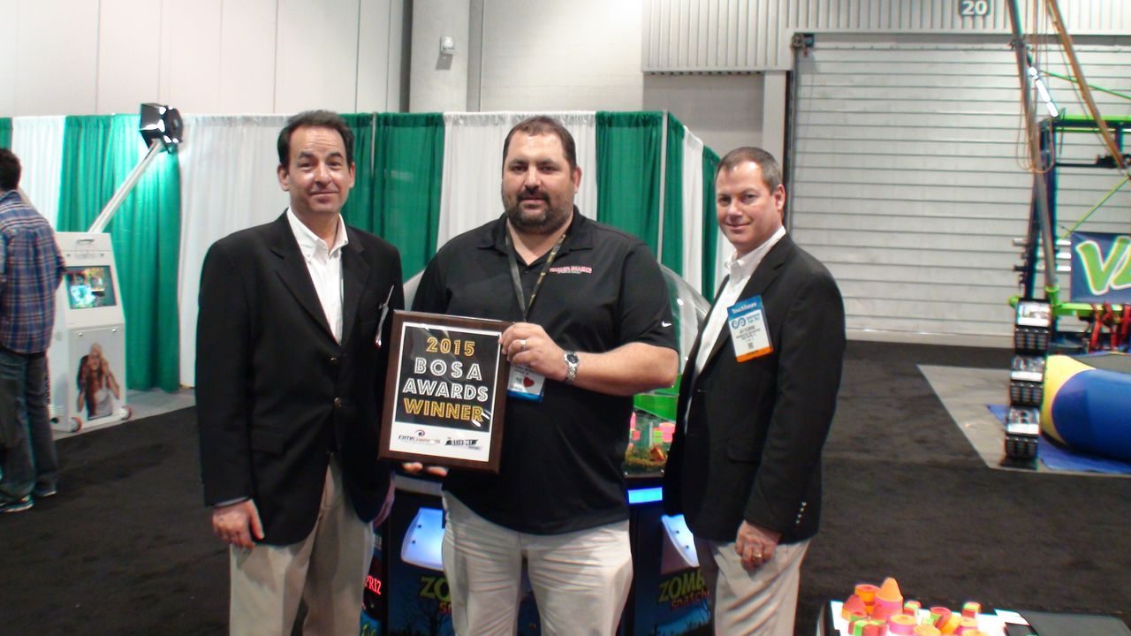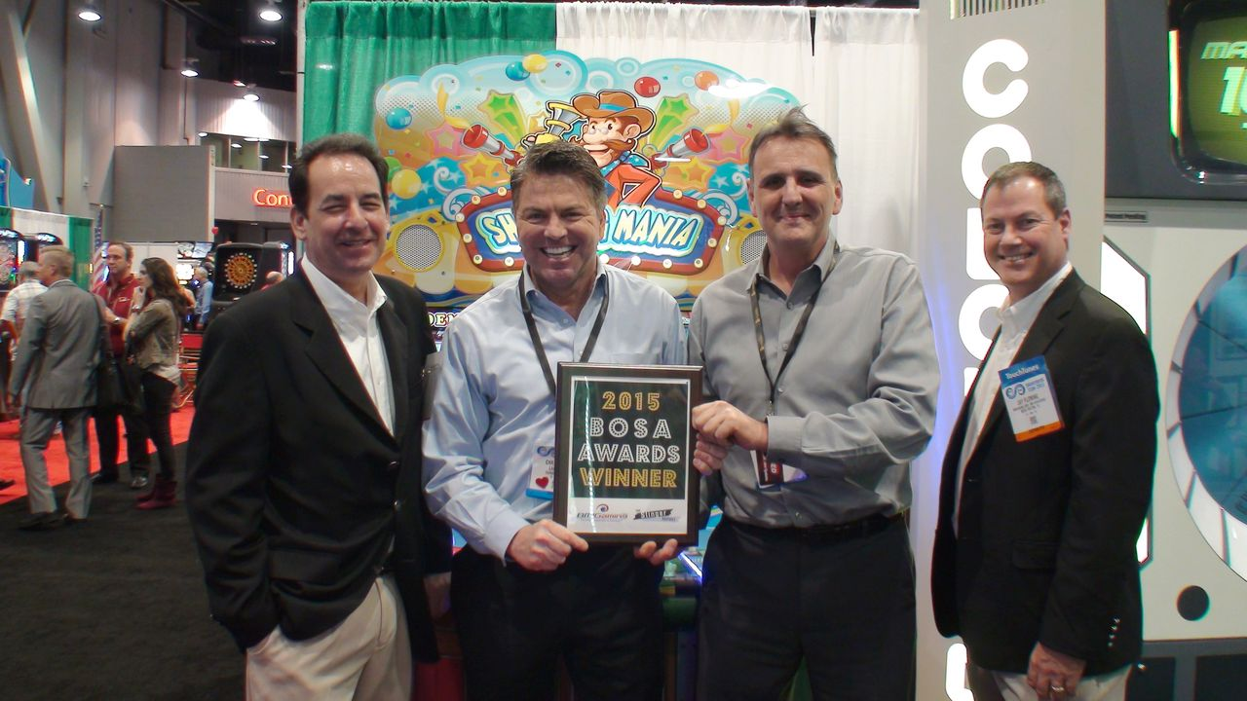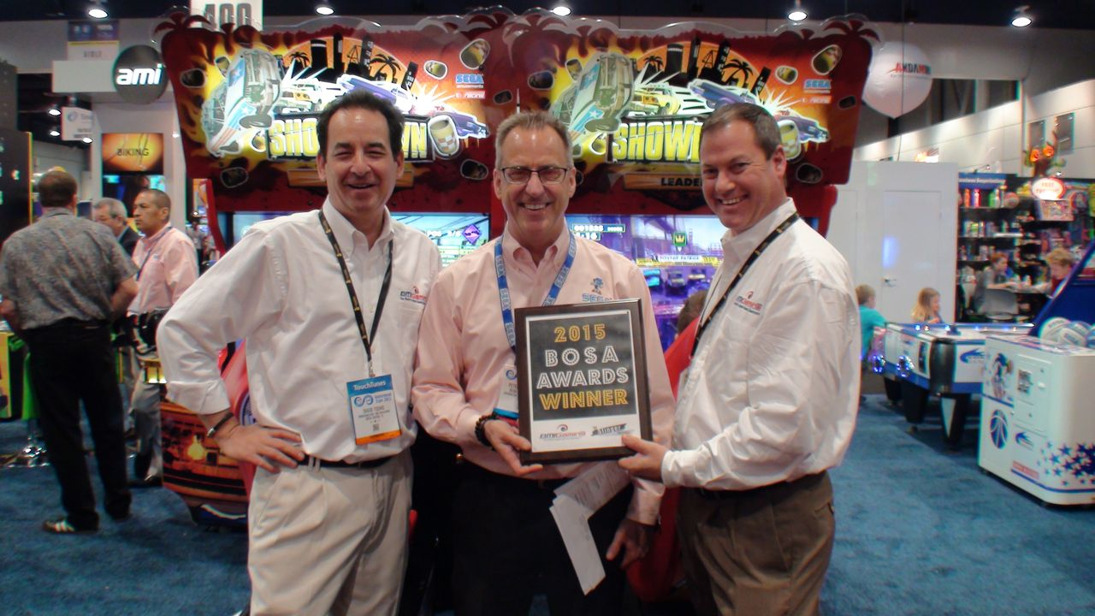

**BOSA Award Presenter Backgrounds**



**BMIGaming.com / BMI Worldwide***BMIGaming.com* is the world's largest online distributor of amusements, arcade and redemption games, motion  
simulators, sports games, kiddie rides, music and vending equipment. It offers customers in over 200 countries  
amusement products from over 90 global manufacturers, and specializes in FEC ( *Family Entertainment Center* ),  
Arcade and LBE ( *Location-Based Entertainment* ) feasibility, design, theme, purchasing and installation services.   
   
Headquartered in Boca Raton, FL, *BMI Worldwide* (parent of *BMIGaming.com*) has regional sales offices in  
Salt Lake City, Utah and Myrtle Beach, South Carolina, with global offices in Bogota, Colombia, Cape Town,  
South Africa and Brisbane, Australia, with additional sales offices to open within Europe and Asia shortly.  
  
[**http://www.bmigaming.com**](http://www.bmigaming.com)  
  
  
 **The Stinger Report / KWP Limited**Based in London, *The Stinger Report* has been commenting on new entertainment trends and amusement  
technologies for over 20 years, and sister firm *KWP Limited* provides entertainment industry consultancy to  
large clients around the world. *KWP Limited* is also the founder of the not-for profit *DNA Association,* which  
focuses exclusively on the Digital Out-of Home interactive entertainment (DOE) sector for its members.  
  
[**http://www.thestingerreport.com**](http://www.thestingerreport.com/) | [**http://www.dna-association.com/**](http://www.dna-association.com/) **Press Contacts / Digital Asset Requests**



**Kevin Williams** | The Stinger Report | London, UK | UK Phone : **+ 44-7785-254729** | Skype : **kevin729**

**Theresa Landman** | BMI Worldwide| Cape Town, SA | US Phone : **+ 561-288-4890** | Skype : **theresa.bmigaming**  
  
  
  
(End)